BOHS Awards Form
This awards form is the record of the nomination for the:
2026 BOHS LEV Practitioners’ Award.
Copies of this form are also available online at:- https://oxyl8.com/
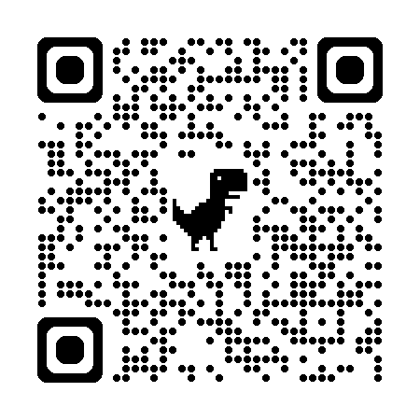
Completed forms should be submitted to:-
Lee Kelly-Burkett
BOHS
5/6 Melbourne Court
Millenium Way
Pride Park
Derby DE24 8LZ

Or via email to – kevin.bampton@bohs.org

The 2026 LEV Practitioners’ Trophy will be awarded to the:-
LEV Specialist/Practitioner, LEV Organisation or Group who in the opinion of the BOHS Awards Committee has:-
“Made a significant contribution to improving health in the workplace”

By submitting this form, you are consenting to:
- share the information that you include in the form; and
- confirm that you have contacted the nominee and have their consent to share information you provide in it.
This information will be confidential to the Head Office staff who manage the awards, the Awards Committee members, and the Board of BOHS (who determine the final winners of any award on the recommendation of the Awards Committee).
Until such time as the Award is announced, the contents of the form will be kept and maintained by BOHS. After this time, a nominator or nominee may ask for details to be removed from the form, but the names and basis of a nomination will be retained so that we have a reference point for future applications.
BOHS will complete further sections in this form as a record of our administrative process and our discussions about award eligibility.
After the announcement of awards, the nominee may request a copy of the form for their own private and confidential use.
The information provided by the nominator in this form is provided to the best of the nominator’s knowledge and is based on personal knowledge or evidence that the nominee has been able to verify.
Award Applied for:  LEV Practitioners’ Award 2026 | Nominee (person, company or group to get the award) | Nominator (person submitting the form)
Email
Telephone
Alternative telephone
Nominee overview |  | Award committee overview
Please provide a brief outline (200 words) of how the nominee meets the award criteria
Nominator comments on criteria 1 & 2 |  | Award Committee Comments on criteria
For the first criteria, please outline:  - a list of achievements that demonstrate how the nominee meets the criterion;  - explain why each achievement is significant, wherever possible using objective measures; and  - please explain how each achievement relates to the focus of the award. | - Achievement 1  - Significance of achievement 1  - How achievement 1 relates to the award  - Achievement 2  - Significance of achievement 2  - How achievement 2 relates to the award  etc
Nominator concluding statement |  | Award Committee conclusion and recommendation
For office use | Date | Actioned by
Date nomination received
Contact detail check
Nominee approval to be considered checked
Form sent to Awards Committee
Considered by Awards Committee
Feedback agreed and collated by Awards Committee
Nomination form submitted to Board with recommendation

