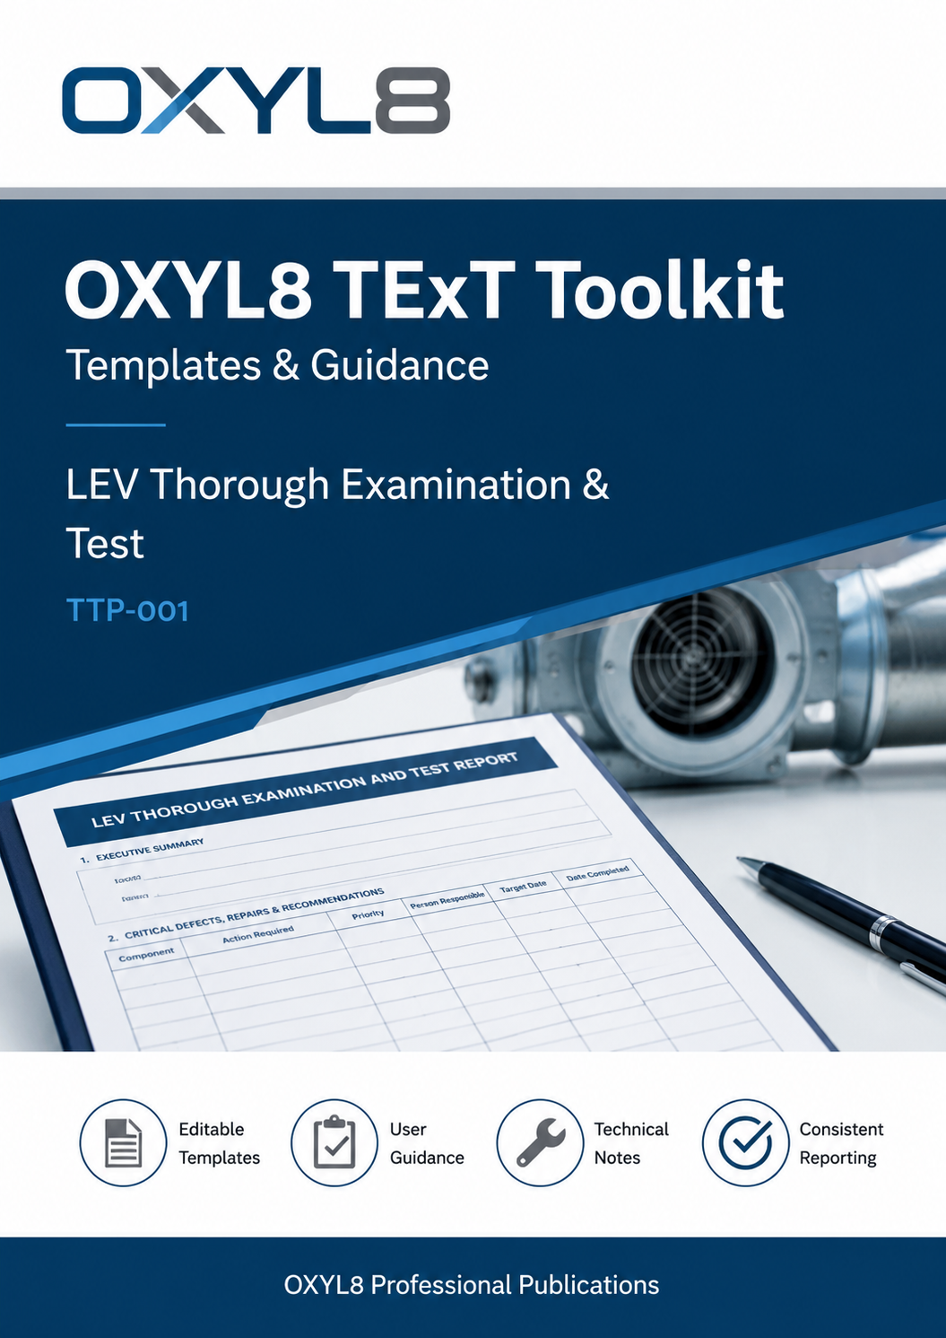


OXYL8 TExT Toolkit

Templates & Guidance

LEV Thorough Examination &

Test

TTP-001
OXYL8 Professional Publications

TTP-001
Version 1.2
August 2026

OXYL8 Professional Publications
Publications within the OXYL8 Professional Publications series are periodically reviewed and updated to reflect changes in legislation, recognised guidance and good engineering practice.

Copyright © OXYL8 Ltd 2026.
This publication may be reproduced in whole or in part for the purpose of specifying, undertaking or reviewing LEV Thorough Examination and Test services, provided that the source is acknowledged and the content is not altered in a way that misrepresents its original intent.
Whilst every effort has been made to ensure accuracy, OXYL8 Ltd accepts no liability for any loss arising from the use of this publication. Competent professional judgement remains essential in every application.

Introduction
Thorough Examination and Test (TExT) is a statutory requirement under Regulation 9 of the Control of Substances Hazardous to Health (COSHH) Regulations. Whilst legislation requires LEV systems to be thoroughly examined and tested at prescribed intervals, it provides relatively little guidance regarding the format of the documentation, the presentation of evidence or the consistency of reporting.
This publication has been developed to provide a practical suite of templates and supporting guidance intended to promote consistency, improve the quality of TExT documentation and support the production of comprehensive, evidence-based reports. The templates are designed to be adapted to suit individual organisations and different types of LEV systems whilst maintaining a common professional structure.

Why this Toolkit Exists
Considerable variation exists throughout industry in the way Thorough Examination and Test reports are prepared. Whilst many reports satisfy the minimum legal requirement, differences in structure, terminology, recorded evidence and technical content can make reports difficult to interpret, compare and review.
This Toolkit has therefore been developed to encourage a more consistent approach to TExT documentation. It provides practical templates, supplementary schedules and supporting guidance intended to assist competent practitioners in recording examinations in a clear, structured and evidence-based manner, whilst also helping Duty Holders understand the information being presented.

Purpose of this Toolkit
This publication brings together the principal documents required to prepare and customise OXYL8 Thorough Examination and Test documentation.
It includes a standard TExT template suitable for most LEV systems, an additional schedule for partial enclosure systems, guidance explaining how the templates should be completed and a technical guide describing how the embedded calculation tables may be amended where necessary.
The publication is intended to provide a practical working resource for competent LEV practitioners whilst also promoting greater consistency in the presentation of technical evidence provided to Duty Holders.

It is not intended to replace COSHH, HSG258 or other recognised guidance, but to complement those documents by providing a practical, structured framework for the preparation and presentation of Thorough Examination and Test documentation.

Relationship with MPS-001
This Toolkit has been developed to complement MPS-001 – Procurement of LEV TExT Services.
Where MPS-001 assists Duty Holders in specifying the scope and quality of TExT services to be procured, this Toolkit provides practical templates and supporting guidance to assist competent practitioners in recording those services consistently and comprehensively.

Evidence-Based TExT Reporting
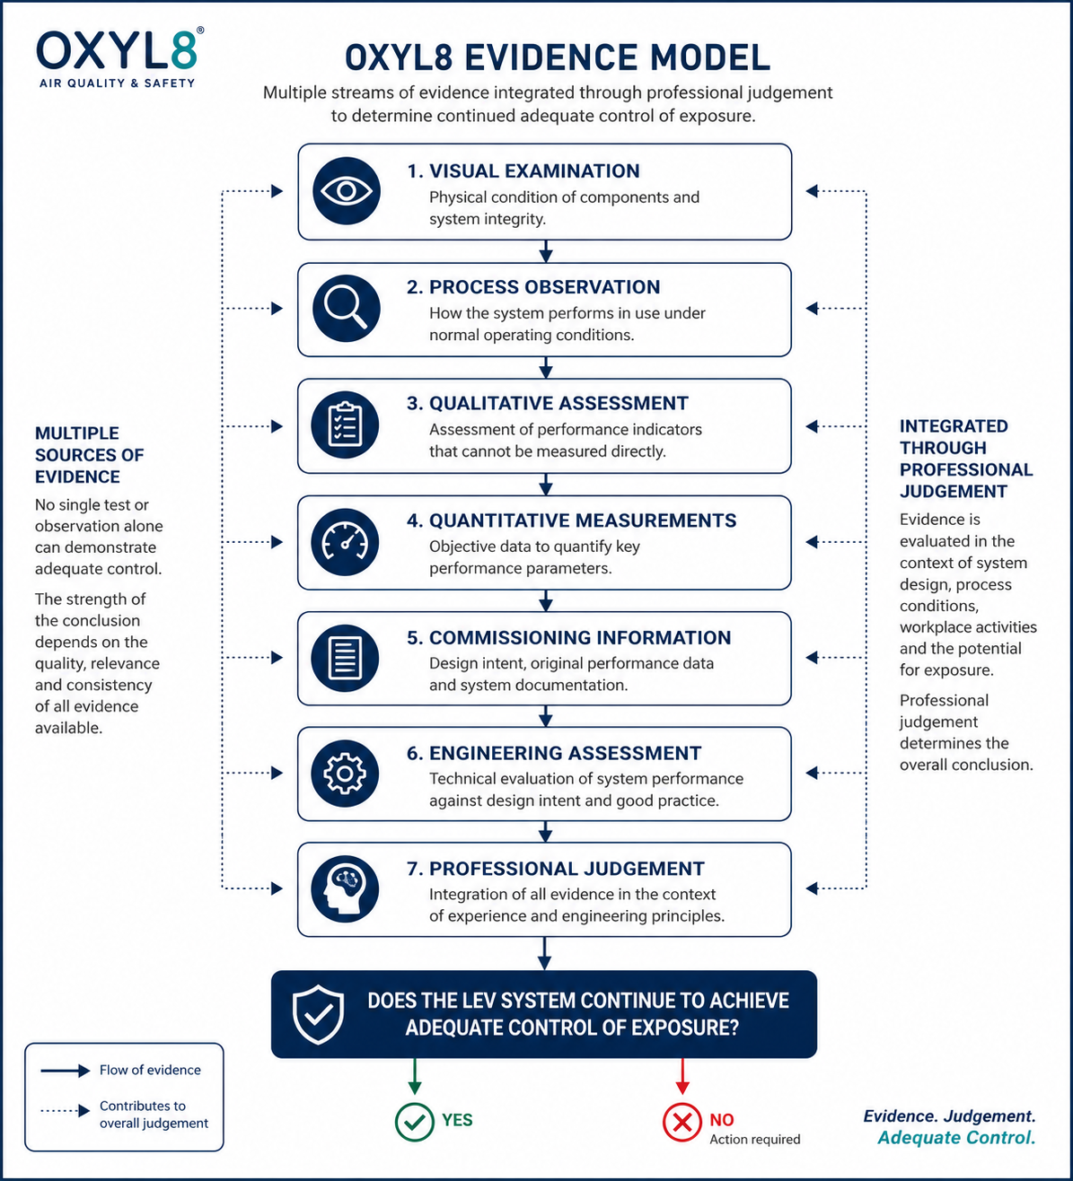
CONTENTS

1. Part A - Blank TExT Template

2. Part B - Partial Enclosure Supplement

3. Part C - Template User Guide

4. Part D - Template Technical Guide (Template Modification)

1. Using this Toolkit

- Use Part A for all LEV systems.
- Use Part B only where partial enclosures are present.
- Refer to Part C for completion guidance.
- Refer to Part D only if modifying the Word/Excel template.

The templates should be reviewed and amended where necessary to suit the particular LEV system.
Part A

Blank TExT Template

The following template has been developed to provide a structured format for recording LEV Thorough Examination and Test findings.
It may be adapted where necessary to suit the LEV system being examined whilst maintaining the principles described within this Toolkit.

The OXYL8 TExT Template is supplied as an editable Microsoft Word document incorporating embedded Microsoft Excel calculation tables.
The latest version may be downloaded from:

https://oxyl8.com/

COMMISSIONING/INITIAL THOROUGH EXAMINATION AND TEST REPORT (TExT)
LOCAL EXHAUST VENTILATION (LEV) PLANT

SUMMARY OF ASSESSMENT OF CONTROL

SATISFACTORY

Refer to next page for Defects & Recommendations

SITE DETAILS & SYSTEM ID
Client/Duty Holder Name |  | System ID
Site Address |  | Location of LEV
Date of TExT |  | Date Next TExT Due
Brief Description of Process |  | Hazardous Substances Used or Produced

TExT EXAMINER/COUNTERSIGNATORY
Examiner Name | Designation | Date | Signature
Qualifications |  | Certificate No(s)
Countersignatory | Title | Date | Signature
Report Accepted By | Title | Date | Signature
1. EXECUTIVE SUMMARY

2. CRITICAL DEFECTS, REPAIRS & RECOMMENDATIONS
TExT Examiner |  |  | Duty Holder
Component | Action Required | Priority* | Person Responsible | Target Date | Date Completed
Critical Defects Background Shaded RED
* add in a priority code - eg 1 = High, 2 = Normal, 3 = Routine, 4 = Awareness
3a. GENERAL DESCRIPTION OF LEV SYSTEM

3b. PHOTOGRAPHS

3c. SCHEMATIC LAYOUT OF LEV SYSTEM

4. DESCRIPTION OF TExT METHODOLOGY USED

5a. ASSESSMENT of CONTROL
TExT Undertaken with Plant/Process & LEV Operating Normally? | Yes/No
If NOT Normal Operations etc – System Test & Evaluation Method(s).
Description of Hood Types & Arrangement
Hoods Suitable for the Process BENCHMARK? | Yes/No/Not Known
Number of Hoods on System
Max No to be used/open at any one time
Description of Alarms/Indicators/Gauges Fitted?
Description of How Controls Were Observed Being Used by Operators

5b. ASSESSMENT of CONTROL - VISUAL/QUALITATIVE TEST REPORT
Visual Inspection Report
Qualitative Test Undertaken? | Yes/No
Description of Technique(s) Use
Were Process Emissions Visibly Controlled? | Yes/No
Instruments Used in TExT | Serial No | Last Calibration Date

6. TExT FREQUENCY
Interval between TExTs | months
Next TExT Due:

7. DOCUMENTATION AVAILABLE
Commissioning Report | Yes/No/Not Applicable
LEV System Manual | Yes/No/Not Applicable
LEV Logbook | Yes/No/Not Applicable
CoSHH Risk Assessment | Yes/No/Not Applicable
DSEAR Risk Assessment | Yes/No/Not Applicable

8a. OCCUPATIONAL HYGIENE
Substances USED in Process | Substance | Hazard Band | WEL
Substances PRODUCED by Process | Substance | Hazard Band | WEL

8b. OCCUPATIONAL HYGIENE MONITORING
Has Exposure Monitoring been undertaken in this area? | Yes/No
If “Yes” insert Date of Survey:
Survey Findings - Summary

9. FAN SPECIFICATION & TEST RESULTS
Fan Manufacture and Type
Model/Size
Serial Number
Design Duty Flowrate (m³/s)
Drive Type
Measured Fan Shaft Speed (RPM)
Motor Rating (KW)
Impellor Type
Intended Direction of Rotation
(as viewed from motor side of fan)
Confirmed Fan Rotating in Correct Direction | Correct/In Reverse
Method Used to Determine Direction
Fan INLET Static Pressure (Pa)
Fan OUTLET Static Pressure (Pa)
General Comments

10a. FILTER/AIR CLEANER SPECIFICATION If no Air Cleaner – go to Section 11
Filtration Arrangement
Filter Make and Model
Serial Number
Manufacturer’s Duty Flowrate (m³/s)
Design Pressure Loss (state if Range) (Pa)
Filter Cleaning Method
Differential Pressure Gauge Fitted? | Yes/No
Prefilter Installed (If ‘Yes’ add Type and Grade) | Yes/No
Primary Filter Type
HEPA Filter (if ‘Yes’ add Grade) | Yes/No
General Comments

10b. FILTER EXAMINATION & TEST RESULTS
Measured Flowrate (m³/s)
Pressure Drop at TExT (Pa)
Filter Media Condition
Evidence of Breakthrough into clean area?
Recirculation Filter on System? | Yes/No
Recirc Filter – Breakthrough Measured?  (If “No” …. Explanation) | Yes/No/Not Applicable
Recirculation Filter - Technique for Measuring Breakthrough
Results of Breakthrough Test
Cleaning Mechanism Operating Correctly? | Yes/No/Not Applicable
Condition of Door/Panel Seals
General Comments

11. DSEAR/ATEX If no applicable – go to Section 12
Do DSEAR/ATEX Regulations Apply to this Process? IF “NO” – Go to Section 12. | Yes/No
If Filtered – Explosion Relief Fitted? | Yes/No
If “Yes” – Does it Vent to a Safe Place?  Comments on Suitability of Installation | Yes/No
Rotary Valve on Filter Discharge to Bin? | Yes/No/Not Applicable
Non-Return Valve on Ducting? | Yes/No/Not Applicable
Earth Bonding on System? | Yes/No/Not Applicable
Other DSEAR/ATEX Comments

12. DUCT SPECIFICATIONS
Ducting Type(s)
Inspection Hatches Fitted? | Yes/No/Some
Internal Inspection Carried Out?  Explanation of Method Used | Yes/No
Ducting Balanced/Re-Balanced | Yes/No/Not Required
Duct Condition Report
(Internal & External)

13. STACK/TERMINATIONS If not applicable – go to Section 14
Description of Discharge Arrangement
Stack Height (from roof level) – (m)
Sufficient to Ensure Dispersal? | Yes/No
Type Weatherproof Termination?
Comments on Discharge Arrangements:

16. REFERENCES
HSG258; Controlling Airborne Contaminants at Work, A Guide to Local Exhaust Ventilation; 2017, ISBN 978 0 7176 6613 3
L5 The Control of Substances Hazardous to Health Regulations (CoSHH) 2002, Approved Code of Practice and Guidance (6th Ed), 2013, ISBN 978 0 7176 6582 2
The Management of Health & Safety at Work Regulations 1999; 2007, ISBN 978 0 7176 2488 1
The Dust Lamp – A Simple Tool for Observing the Presence of Airborne Particles, MSE MDHS 82/2, 2015
Workplace Exposure Limits HSE EH40/2005, 4th Edition 2020 ISBN 978 0 7176 6703 1
Industrial Ventilation; A Manual of Recommended Practice for Design, 31st Edition, ACGIH 2023, ISBN 978 1 6072 6161 2

Appendices

Part B

Partial Enclosure Supplement

The following supplement should be used in conjunction with Part A where the LEV system incorporates a fume cupboard or other partial enclosure.
A separate copy should normally be completed for each applicable hood.

coshh reg 9 text form

PARTIAL ENCLOSURE SUPPLEMENT

AddiTIONAL INFORMATION SPECIFIC TO FUME CUPBOARDS AND OTHER PARTIAL ENCLOSURES

A.1 System & Hood Details
SYSTEM ID

HOOD ID:

Location:

Description:
(inc Name/Type of Unit)

Category:

Process & Contents
(at time of Inspection):

Discharge Arrangement:

Photographs:

B.1 Visual Inspection
Condition of:

Sash glazing, Runners, Inner Work Surfaces:

Baffle:

Condition?
Correctly set?
Obstructed?

Sash:

Sash Opening Height Limit Stop fitted?

Stop Height Labelled/Marked?

Sash Height at Stop (mm)?

D.1 REFERENCES
HSG258; Controlling airborne contaminants at work. A guide to local exhaust ventilation (LEV); HSE Books
BS EN 14175 Parts 1 – 7 Fume Cupboards
BS 7989:2001 – Recirculatory Fume Cupboards
BS EN 12469/BS 5726 – Microbiological Safety Cabinets

Part C

Template User Guide

The following guide was originally issued as Version 24.1 in June 2024 and is reproduced within TTP-001.

TExT Templates
User Notes & Guidance

August 2026
V26.1

A Few Words

This guide is not intended to be a definitive description or specification as to how to undertake a CoSHH Reg 9 Thorough Examination & Test (TExT).

It is a companion guide for use with the two versions of the OXYL8 TExT Template.

Word version
Word/Excel embedded version

There may be errors and omissions – if so please get in touch using the email address below to let us know:-

admin@oxyl8.com

We are hoping this could evolve into an LEV community owned guide and so additions for updates and ideas are most welcome.
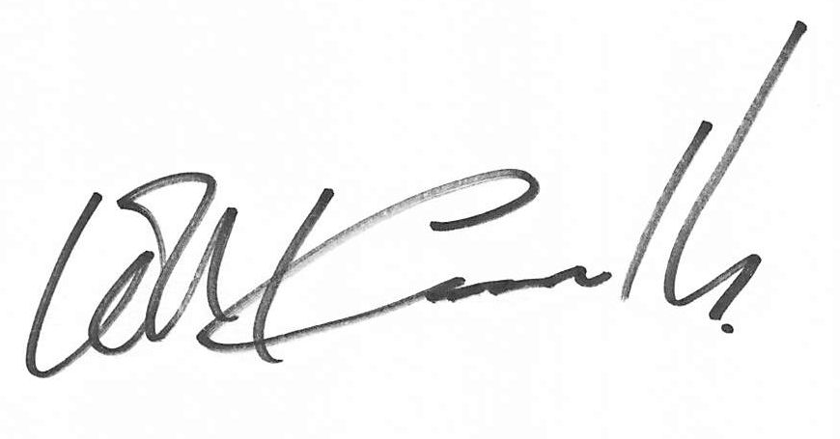

Bill Cassells
12.08.26

OXYL8 TExT Templates (Word & Word/Excel)
There are two (similar) downloadable versions of the TExT template – both available from https://oxyl8.com :-
- Word format with no calculations embedded.
- Word/Excel hybrid where hood and duct calculations are performed automatically

Note: If using the Word/Excel ‘embedded’ version of the Template – double mouse click on the embedded table to open it out as an Excel table. Then enter your data. When finished – click again outside the table (once) on the document part and it will close the table again. Simples?

General Introduction
Both templates can be readily amended to suit your particular requirements. The associated “Template Technical Guide” describes how to change/amend the embedded tables/calcs version.
The Templates are not ‘fixed’ formats but are intended to be modified by you to suit your specific requirements. Similarly, they have not been ‘specified’ or ‘designed’ by any formal authority nor are they officially ‘approved’ by HSE etc.
Representatives from HSE, BOHS and other LEV Specialists have however contributed to and commented on the structure and content of the Templates.
Without guarantees – they are most likely to satisfy even the most rigorous scrutiny .
What they do is provide an excellent model from which you may base your own bespoke corporate TExT Templates.
Don’t be put off by the extent and complexity of the contents of these Templates. Some elements may not be relevant or appropriate to the type of work you do.
However – please note - it would be true to say that there are too many ‘thin’ LEV TExT Templates out there. The days of the 2 or 3 page TExT Report are now long gone. Be warned!
LEV TExT work is not ‘Rocket Science’ but you do need to follow carefully the requirements and guidance contained in the CoSHH Regulations L5 – particularly paras 169 to 197. And, especially paras 186 & 189.
It is your conformance with paras 169 to 197 on which you will primarily be judged! A PDF copy of COSHH Regulations L5 can be downloaded here: https://www.hse.gov.uk/pubns/books/l5.htm
OXYL8 provide these TExT Templates for all LEV Practitioners to use on an open-ended free-to-use licence basis (although OXYL8 Ltd do retain final copyright of the base Templates).
So far so good. But?
Feedback from HSE Inspectors indicates that although they frequently see Templates which reasonably satisfy CoSHH requirements they do still regularly find that the quality and competence of completion of the TExT Reports has some way to go.
So? What follows is a brief guide to some of the elements and issues to be careful of when completing these Templates.
Where the Notes below relate to Box numbers – these are the numbers as on the original base Templates version (ie before any of your own in-house modifications).

Additional Helpful Comments
Boxes should be filled in and not left blank.
If the box does not apply – say so. Using N/A or N/R if necessary. If the information required for the box cannot be obtained (for operational or safety reasons etc) – say so!
Some boxes – eg, Methodology, Instruments used, References, etc may contain information that is common to a number of TExT reports being undertaken at a single location. In such cases the contents of these boxes could be removed from the individual TExT forms and put as a single Appendix covering all the TExT Reports for that location.

Must “Test as Found”!
HSE have commented that LEV testers have been observed servicing the LEV system and then undertaking the TExT. This was not the accepted method! Having completed the TExT and service – and especially so if the results were significantly different before servicing and after – do consider if the current interval between services is appropriate and advise the Duty Holder accordingly.

Repeat TExT Failures?
HSE have suggested that in these circumstances the LEV Examiner should state in the TExT report something along the lines of - “this fault was present at previous TExT and no action has apparently been taken to rectify”.

Can TExT/Commissioning Engineers combine their Reports into one (saving duplication)?
HSE has indicated - “Yes – but each test has specific requirements and data to be recorded. So long as this is recognised by the LEV Specialists, there is no reason why they could not be combined in to one Report”.

Front Page
It is more normal for the main box to state either “Satisfactory” or “Unsatisfactory” and with appropriate Green/Red background shading.

Satisfactory/Unsatisfactory Box
Note if there are significant defects – then the TExT cannot be marked as “Satisfactory” by stating something like “Satisfactory on Completion of Repairs listed below”!
What about these scenarios:-
- The LEV system is functioning appropriately and is capable of controlling the emissions – but the operators are misusing the LEV?

- There are significant DSEAR/ATEX issues – which are not strictly part of Reg 9 TExT?

On the first scenario – in discussions with HSE representatives they indicated that where the physical ‘LEV System’ was “Satisfactory” – and it was an issue with operators’ misuse – they would be unhappy with a normal ‘Green/Satisfactory’ marking as there could be a risk the Duty Holder would see the “green” and file the Report..
It was suggested that an “Amber” background shading to the “Satisfactory” box could be used. That they felt would be more likely to alert the Duty Holder to the issue.
On the second situation – HSE have made it quite clear on several occasions that DSEAR/ATEX issues that are ‘obvious’ should be picked up and reported to the Duty Holder. A senior HSE representative has stated in the past that a TExT Examiner could be in breach of S3 of the HSAWA 1974 if they failed to report such issues.
But how to report? Again the use of an Amber shading to the Satisfactory box could be used?
In both the above scenarios (and there could be others) – some TExT Specialists have split the “Satisfactory box” into two – with a Green shading and “Satisfactory” on one part headed “Effectiveness of Control of LEV” (or something like that) and a Red “Unsatisfactory for the other side of the box where it would be headed “Use of Controls”.
A similar ‘split box’ arrangement could be prepared for “DSEAR/ATEX” issues.

HSE’s view on a multi-hood system where only one hood was “Unsatisfactory” and other were OK? How to report in a TExT?
An HSE representative has suggested - could look to possibly using the Amber “Satisfactory” marking – or possibly even to split the Satisfactory/Unsatisfactory box into 2 and indicate the issue with an “Unsatisfactory Hood X”?
HSE indicated it would not normally be necessary to fail the whole system but added the usual caveat of – the final decision would depend on the substance, the risk and the process!”.

LEV performing adequately but significant issues eg hole in duct, rattling fan, torn hood?
HSE’s view has been that the system should be “classed as “Unsatisfactory” until such issues rectified. The poor condition is a breach of CoSHH Reg 9(1)”.

Site Details & System ID Box
Do NOT enter a “Date of Next TExT” if you have marked the system as “Unsatisfactory”!
The Process description – although ‘brief’ (and not an ‘essay’) does still need to provide adequate information for the reader to understand exactly what is going on.
As an example - do not state something like “Welding”. In this case you would need to provide details of the overall process and what specific type of welding was being undertaken (MIG, TIG, Stick etc), what the base materials were and some info on the consumables. Finally, we would need an ‘estimate’ of the “Arc Time”.
You can extrapolate the style of the above answer details/descriptions to “Painting”, Woodworking” and all other processes you may come across.
You should also provide here a “Brief” description of the hazardous substances “USED” in and “PRODUCED” by the Process.
More detailed information will need to be recorded at Box 8a.

TExT Examiner/Countersignatory
This section can be modified to suit your in-house requirements and arrangements.
HSE would welcome Cert Nos and PSR Registration details etc to be entered at this section
The “Report Accepted By” is a ‘suggested’ section to be included for the Duty Holder/Client to “accept” the TExT Report on handover.
Box 1. Executive Summary
Provide an overview of what you have found.
Duty Holders will often go to this section of the TExT to get a ‘feel’ for the situation – so it has to ‘grab’ their attention.
In too many cases the Duty Holder will go no further than this section and (probably) the “Repairs/Faults” section of the TExT.
You may also wish to add the following conditional qualifying comment in this section:-
Note: Any changes to the LEV system or significant process changes will render this Report invalid.

Box 2. Critical Defects, Repairs & Recommendations
This section could be split into two vertical sections (as in the Template).
The left-hand column section is completed by the TExT Examiner and the right columns by the Duty Holder (once the faults/repairs have been rectified).
Do NOT indicate there is a fault …. but with no description of the Remedial Actions required.
You should also provide an indication of the “Priority” to be given to each point raised.
A sample Priority Rating has been provided in the Template but you may also develop your own.

Box 3a. General Description of LEV System
Box 3b. Photographs
Provide a description of the overall layout and function of the LEV system. Refer to the Schematic at Box 3c.
Try to have in mind that an HSE Inspector will review this TExT form during a visit to a Duty Holder’s site. This description must therefore provide the Inspector with a clear “picture” of what the system entails.
Include notes on any changes noted since previous INITIAL and/or from the original design/installation Commissioning Report (where appropriate)
The photographs should be large enough to be clearly interpreted and should show the important components of the LEV.
Don’t insert ‘postage stamp’ images.
We would recommend labelling photographs with clear descriptions which also include reference to the significance/importance of the item in the image.
Box 3c. Schematic Layout of LEV System
This can be in any format – hand-drawn, CAD drawing/image etc
But the Schematic must show not only the general layout of the LEV system but should also be annotated with such details … as a minimum:-
- Duct layout, dimensions and test points (marked)
- Hood types, IDs
- Damper positions and special features

Box 4. Description of TExT Methodology Used
A clear description of exactly how the TExT was undertaken – both Quantitatively and Qualitatively – and not forgetting visual inspection methods/scope.
It is acceptable to remove this box to an Appendix covering all TExTs undertaken at a site – saves unnecessary repetition.
Outline all parameters you would expect to measure, eg
- how measurements were taken and instruments/techniques used
- No. readings at a hood face
- No. of Test Point holes at duct position
- How duct traverses were undertaken (eg, ‘Equal Area’ method and how many readings etc)

If required – refer to more detailed Methodology in an Appendix (eg use of equal area duct traverse, face velocity test points chosen etc)

Box 5a. Assessment of Control
Be wary of concluding in a TExT Report that the system is “Satisfactory” when you did not test with both the LEV system and the process running (or a simulation of the process). Otherwise, in many situations this would be an ‘inconclusive/incomplete’ TExT!

You MUST test with the process operating or ‘simulate’ the process (eg, by welding a piece of scrap – or by passing an offcut of timber through the woodworking process etc).
Without that HSE’s view is likely to be “How can you say it’s Satisfactory’ when the process was not operational during the TExT”.
Think carefully how you would respond to that question?
You will see that there is a second row in this section where you can explain what you did do to prove control was being achieved …… if the process was not able to run normally.
HSE have commented that LEV Examiners have waffled on about poor control etc – and missed the ‘elephant in the room’. That is that the specified hood type was the wrong one for the process.
The key to this is Benchmarking and an HSE Inspector intimated that he expected TExT Examiners to be familiar with the concept of Benchmarking – and from that and to make comment on the suitability of the hoods for the process/contaminant involved.

See Appendix 2 (p95) of HSG258 for information on Benchmarking. The OXYL8 App has a menu option for calculating a system/process Benchmark.
Benchmarking is not currently covered in the P601 syllabus but it is covered in P602.
It is expected that a TExT Examiner will observe the operations and in particular observe how the operators were using/interfacing with the LEV Controls.
Is the absence of Indicators/Gauges/Alarms a cause for an “Unsatisfactory” conclusion? Or, if a system was found to have a faulty alarm/indicator …. and if all other tests/observations were OK (including qualitative tests) – would HSE expect that system to be classed as “Unsatisfactory”?
In discussions an HSE representative responded -“Normally “Yes” as the TExT is only undertaken on one day and there are another 364 days in the year where monitoring of the process would be required. But the final decision would depend on the process, risk, substance etc”. If the process and the materials used or produced by the process posed a significant health risk – then it is more likely that an “Unsatisfactory” marking would be considered appropriate. In such situations the process Risk Assessment is clearly the key document to consult.
However - the absence of a hood Indicator/Gauge/Alarm etc should always be noted in the TExT. Although not a mandatory legal requirement for every hood/situation HSE have previously stated that they– “would expect to see them on most hoods and especially on new hoods”.
See this page from HSE’s website on the subject of Indicators/Gauges etc :-
https://www.hse.gov.uk/lev/faqs.htm
HSE have been concerned that TExT examiners were not always observing the processes and how the operator used the hood.

These observations must be noted in the TExT Reports. For example - if the operator was not working within the Captor Distance – although that would not necessarily be an “Unsatisfactory” in its own right a TExT Examiner could use an “Amber” ‘Satisfactory’ marking – meaning the LEV Control itself was found to be ‘Satisfactory’ but a ‘Caution’ raised due to improper use by the operator”.
Some TExT Examiners have split the Satisfactory/Unsatisfactory box into two.
In one box they have the Satisfactory/Unsatisfactory and colouring for the SYSTEM performance – but the second box addresses the Operational aspects (ie Operator working too far from the hood would be a “Red Unsatisfactory”).

Box 5b. Assessment of Control – Visual/Qualitative Test Report
Tick boxes are scorned! Do not use a ‘tick box’ which states “Visual Inspection Completed” ….. tick!!
A “Visual Inspection” – means just that. You will be expected to visually inspect all available parts of the system from the hood to the discharge.
Describe the qualitative test (Smoke/Dust Lamp etc) undertaken. Explain what and how this was carried out and what was observed.
The section on “Instruments Used” and “Calibration” could be removed from every individual TExT and inserted as a single Appendix covering all TExTs for the LEVs examined at a particular site (if the same instruments were used in each situation).
Instruments for Measuring Face Velocity at small Hoods? HSE – are horrified that they are still coming across some testers who were using Rotating Vanes at small captor hoods, eg Welding Hoods!
Remember the instrument should be ‘small’ in comparison with the size of the hood opening and should not in itself significantly disturb the air flows into the hood.

Box 6. TExT Frequency
Do take care not to forget that not all LEV is subject to the “at least once in every period of 14 months” periodicity; ie normally translated as every 12 months.
CoSHH Schedule 4 has some set test interval periods for specific processes which are monthly or 6 monthly. Do consult Schedule 4.
Can we be clear? It is NOT expected that TExTs will be done every 14 months (to ensure we cycle through the seasons) – that is a proverbial ‘apocryphal tale”!
However, in some occasions the TExT Examiner may need to specify a test period of less than 12 months. It is the Examiner’s decision. My view? Do you feel confident to leave the particular system for another 12 months. If not, then consider an appropriate interval and advise the client accordingly.
Remember CoSHH Reg 9 states that testing must be done “at least once” in every period of 14 months etc. It could be ‘twice’, ‘three times, etc
Do Not enter a date for the “next TExT Due” where you have marked the system control as “Unsatisfactory”!

Box 7. Documentation Available

Commissioning Report
The TExT Report – may be combined with the Commissioning Report into one document. Remember though that there are specific requirements for items to be included in a Commissioning Report (see p78 HSG 258) and these must be incorporated if a ‘combined’ document is to be produced.
Often at the Initial TExT the Commissioning Report will be absent.
In such circumstances – there will usually be no LEV system Manual or Log Book.
In such situations – although the ‘ship has sailed’ for the Commissioning Report the client should be advised that an LEV Manual and Log Book must be retrospectively prepared (irrespective of how old the LEV system is) – and that this Initial TExT can be used as a basis for preparing those missing documents.

LEV System Manual and Log Book
These documents are frequently missing. It is not necessarily an “Unsatisfactory” but it must be recorded in the actions/faults/remediations section of the TExT and the client should be advised to have these docs prepared.
HSG258 at p80 provides bullet points on what should be included.
These documents should be ‘readily available’ to all relevant parties; eg TExT Examiner, HSE Inspector, Operators, Management etc. If not ‘readily available’ – that too should be noted in your TExT Recommendations.

CoSHH Risk Assessment
OK – Devil’s Advocate?
How can you competently assess whether an LEV system is providing ‘adequate control’ if you do not have relevant information on the process risks …. And therefore the level of control to be achieved?
If there is no Risk Assessment then the TExT examiner may need to state that the TExT was “inconclusive”? Why?
Well under Regs 6 & 7 of CoSHH the Reg 6 Risk Assessment will state what controls (under Reg 7) are required and why – and their importance/function etc. You are ‘flying blind’ to some extent without a Risk Assessment.

DSEAR Risk Assessment
Are any of the substances – used in or produced by the process capable of introducing a fire/explosion risk? If so a DSEAR Risk Assessment should have been prepared by the client. They are sometimes absent .
It has been argued that DSEAR is not an issue of consequence to a TExT Examiner as TExTs are conducted under Reg 9 of CoSHH which has no bearing on DSEAR?
But? You must be aware that S3 of the Health and Safety at Work Act 1974 does apply to you – and will cover your specialist knowledge areas – ie LEV. You will be expected to detect and uncover ‘obvious’ DSEAR issues/failings etc.
What could ‘obvious defects’ be?
Examples; no explosion vent on the filter, or the vent venting to an unsafe position/place, no back-draft damper, no earth bonding, no rotary valve between filter and collection bin etc.
The DSEAR Risk Assessment will have identified what protective devices should be present on the system – and the TExT Examiner should therefore consult the Risk Assessment and check that the required protective devices are in place and functioning correctly.
OXYL8 MasterClass OXY103 – introduces DSEAR/ATEX for LEV Specialists in a one-day informative presentation - see OXYL8 website https://www.oxyl8.com/product/oxy103/ for dates and details.

Box 8a. Occupational Hygiene

Substances
Not all TExT Examiners make the distinction between Substances USED in the Process and substances PRODUCED by the process. Both are important.
Note: “Welding Fume” is not a substance – it is an (often) unique mixture of substances.
You need to be specific here and list constituents of any ‘fume’.
“Wood dust” is meaningless. What type of wood? Softwood? Hardwood? Or a mixture.
‘Paint Fumes’ – or ‘Paint Spray’ – again – meaningless. Specify the individual components that may be present.
Be descriptive and inclusive!

Hazard Band
Every substance can be allocated an appropriate Hazard Band (Band range from ‘A’ to ‘E’). The methodology is described in HSG258 at page 95.
The OXYL8 App (free to download from your App Store by a search our company name OXYL8) …. can also be used to automatically select an appropriate Hazard Band.
Either way – you will need a Safety Data Sheet for the substance to be able to determine the appropriate Hazard Band.

Workplace Exposure Limit (WEL)
Many of the substances you will find in the processes to be LEV tested will be listed in the HSE guide EH40/2005 - pdf copy can be downloaded here:- https://www.hse.gov.uk/pubns/priced/eh40.pdf
If the substance is listed insert the WEL - and any specific abbreviation listed for the substance in the “Comments” section of the EH40 tables; eg Sen, Carc.

Box 8b. Occupational Hygiene Monitoring
The ACOP to the CoSHH Regs 2002 at para 186 states:-
“A suitable record in respect of each thorough examination and test of LEV should normally contain the following elements …… the results of any air sampling relevant to LEV performance”.
A TExT Examiner must therefore ask the Duty Holder if any occupational hygiene air monitoring has been undertaken (in the area of concern). In many cases the answer will be in the negative.
HSE have noted that TExT examiners are frequently not asking if occupational hygiene monitoring has been carried out!
In HSE’s view the LEV system control assessment could potentially be ‘Control Not Determined’ without this – depending on circumstances. Bear that in mind.
But what to do if the Duty Holder has a survey report?
In addition to the date of the survey you need to make summary comments on the findings.
Were the levels of exposure above the WEL? Near the WEL?
What about the figures sometimes banded about of 1/3rd or 1/10th of the WEL? This is where Hazard Banding from Box 8a. comes into play.
Exposures should be kept below any WEL but as a general guide we want the LEV Controls to reduce exposures down to a fraction of that.
It has been suggested that for substances in Hazard Bands “A” and “B” for example we would be looking to control down to a 1/3rd of the WEL. For “D” and “E” – down to a 1/10th of the WEL,
Note: These are not mandatory but if the levels exceed 1/3rd or 1/10th in the respective Bands then in my opinion we should be looking carefully at ways of improving the LEV (and associated) controls.
Now look at the Survey Report and relate the findings to the above wherever possible.

Box 9. Fan Specification & Test Results
Much of this box is self-explanatory. But?
How many fans are estimated to be running backwards? According to an (admittedly fairly old) HSE survey – up to 8%! That’s about 1 in 12.
HSE have observed and commented that “Still too many fans being discovered in this condition and HSE are concerned that not all TExT Examiners were physically checking for correct direction of rotation for every fan at every TExT”.

So, if you are not occasionally recording that a fan was found to be in reverse – you could be at risk of being accused of not being sufficiently ‘thorough’ in your work .
In our view the best way of checking fan direction is to use a “Contactless Phase Rotation Tester” – see:
https://levshop.co.uk/product-category/purchase-lev-test-equipment-accessories/fanrotationtesters

Box 10a. Filter/Air Cleaner Specification

General
Again, information to be recorded this box is fairly straightforward.
If you require additional information rows/lines within this box – see the associated “Template Technical Guide”.
Do (wherever appropriate) open filters and examine the internal conditions, checking that the filter cleaning mechanism is operational and effective. Look for holes, blinding etc.
On standard bag filters there is often a top inspection panel which can be removed. This usually gives access to the ‘clean’ side and significant dust in this area can indicate filter break-through.

Recirculating Filters?
Recirculation filters are becoming increasingly common (mostly particulate – but some are carbon/chemical filters). Installation costs are minimal – no ducting/weatherproof terminations etc – and they are very energy efficient.
HSE have observed that TExTs they review …. frequently fail to properly incorporate the CoSHH ACoP requirements .
Para 189 of CoSHH ACoP states; “…… systems which return exhaust air to the workplace: filter efficiency; and concentration of contaminant in returned air”.
HSE - “Testing the effectiveness of recirculation filters at TExT is expected and required. To do nothing is not an option!”. You have been warned!
Practitioners should consult the latest HSE guidance concerning recirculating filtration systems and prepare a suitable test methodology appropriate to the contaminant and filter type. For particle ‘breakthrough’ testing, instruments such as these could be considered:-
https://levshop.co.uk/product-category/purchase-lev-test-equipment-accessories/particle-counter-purchase-lev-test-equipment-accessories

For chemical breakthrough testing this instrument could be considered:-
https://ribble-enviro.co.uk/product/multirae-lite/

Spray booths, Pleated Filters etc?
  - For concertina filters at the back of booths the best angle for the pleats is just under 90⁰
  - Do face velocities at booth entry face and at back wall (pleated filters)
  - For the pleated face may well have to use (or mock-up) a device such as a Top Hat to be able to take meaningful readings

Box 11. DSEAR/ATEX

Should TExT examiners report DSEAR issues? Should they be noted on the TExT Report?
LEV Specialists have argued that as DSEAR aspects are not part of CoSHH then it is not relevant to consider them when undertaking LEV TExTs.
This was put to HSE who responded that in their view “TExT Examiners MUST report on any “obvious” DSEAR defects discovered during a TExT – so most emphatically “Yes” it is expected otherwise HSE would see any omissions as potentially a breach of the TExT Examiner’s duties under S3 of HSWA 1974!”
They elaborated that it was “Not necessary for DSEAR defects to be included in a TExT Report but “a” report of the issue(s) “must” be submitted to the Duty Holder in some format or other”.
It was also suggested that an amber marking could be made in a TExT report and then list as a critical defect – (which would be unusual as critical defect would usually be “unsatisfactory”.).
Again, some TExT companies incorporate an additional box on the front page relating exclusively to DSEAR issues (with the usual red/green markings) – thus combining DSEAR into the TExT Report.
For the purposes of the TExT Template DSEAR is incorporated in this section and at the very least acts as a ‘prompt’ for the LEV Examiner to consider DSEAR.
The Template can be amended at this part to suit individual TExT companies’ views and ideas.

Box 12. Duct Specifications
General description of the duct type and layout, including the duct material, shape, sizes and fittings (dampers, inspection hatches etc)
Feedback from HSE has indicated that often TExT Examiners are not internally examining ductwork at each Test Point.
Borescopes are inexpensive and readily available for this purpose. Recommend that you buy one with internal memory storage.
https://levshop.co.uk/product-category/purchase-lev-test-equipment-accessories/borescopes

Box 13. Stack Terminations
If there is a discharge stack it should be inspected/examined. Apparently HSE are still (2024) seeing too many TExT reports where the stack arrangement and stack height are not being addressed.
Can we also be clear – if the discharge could have contaminants in the airstream (ie not simply waste heat/stale air) then Rain Caps should NOT be used.

What is an appropriate stack height?
For many years HSE’s guides have indicated a “minimum of 3m above the highest point on the roof within a 5m horizontal radius”, however HSG258 (p62) now states “Discharged air must leave the duct at a high enough speed to make sure it is dispersed”.
And at p63 “Taller stacks prevent the mixing of the discharged air with the Boundary Layer, but these may not gain planning approval. The Environment Agency or local authorities may have stipulations for stack height”.
In discussions with HSE it is clear that they prefer the Environment Agency’s guide “H1 Technical Guidance Note – Dispersion” should be used when calculating appropriate stack heights. The problem is that this document was withdrawn by the EA in 2016. An old copy can still be downloaded here:- https://levcentral.com/resources/h1-formerly-d1-stack-calculation/
It is not an easy read . When the calcs are run with many variables, often the answer for the stack height is one between 2.2 and 2.8m tall. Is that the origin of the old 3m guide?
So, 3m is still a good generic minimum stack height – unless a shorter stack can be proven to be (or likely to be) effective – eg by using EA’s guide H1.

Box 14. Duct Quantitative Measurements
Table 14 in the Excel embedded Template will automatically calculate (temp corrected) Duct Velocities and Duct Flowrates from average Velocity Pressures.
If using the pure Word Template do remember to correct for duct airstream temperatures.
The Templates assume circular duct which are the norm in LEV. If your ducts are not circular you may have to amend the table.
Do NOT be tempted to use a hot wire anemometer to take velocity readings in a duct!

Test Point Position?
When measuring velocities in ducts if Test Points cannot be positioned greater than 4 duct diameters downstream of turbulence etc – then must state why in TExT Report.
This is less critical for Test Points where only Static Pressure will be measured.
All Test Points must be clearly marked.
Labels available here:- https://levshop.co.uk/product/test-point-labels-100

Duct Velocity Pressure (Vp) Measurements?
Two test holes at right angles to each other is the normal requirement. Don’t be tempted to use just one hole.
Vp measurements should be taken by taking a traverse through each test hole. Remember both tubes connected to the manometer and Pitot.
It is usual to find a variation in the Vp across the traverse of a duct and for that reason a number of readings – depending on duct diameter – but between 6 and 10 on each traverse - should be taken (meaning a total of 12 or 20 Vp readings).

Duct Velocity Insertion Points on Each Traverse?
At the bottom of Table 14, - there is a box to enter the Methodology used to collect Duct Velocity Pressure measurements.
At Commissioning (and at balancing) – HSE have indicated that they would normally expect the Equal Area Method to be used to determine insertion distances for measurements on each traverse.
This method is described in:-
ACGIH Manual 31st Edition at Appendix C-5
https://levshop.co.uk/product/acgih-lev-design-manual-30th-ed-2019 and
BSRIA Guide “Commissioning Air Systems”
https://www.bsria.com/uk/product/qB4YRr/commissioning_air_systems_bg_492015_a15d25e1/
For normal routine TExT work it has been indicated that 6/10 readings on each traverse would be required but not necessarily on the Equal Area insertion point; an equal spacing across the traverse may suffice.

Calculating Velocity from Vp
It is most common to simply add the 12 or 20 duct Vp readings together to get an average Vp and then to use the standard equation V = 1.29√Vp to convert that to an average duct velocity in m/s
But Be Aware - the above “standard/simplified” equation only works for duct temperatures 20⁰C. The correct equation is V = √(Vp/0.5ƿ) where ƿ = air density at the duct temperature.
The Word/Excel embedded Template will calculate the corrected Duct Velocity automatically for temperature – but if using the Word only version of the Template – you will need to correct the Duct Velocity for duct temperature.
There is an argument that the correct mathematical way to obtain the average Duct Velocity is to take each one of the duct Vp readings (12 or 20) and to apply the V = √(Vp/0.5ƿ) equation to each Vp individually and then to average the results. True, that is mathematically more precise, but few Testers do that. In practice I’ve noticed a very small error margin between each of the methods.

Transport Velocities
The standard Transport Velocities are listed in HSG258 (p54).
What if the actual Measured Duct Velocity is less than the Transport Velocity. Is that a fail?
We posed this question to HSE and received this answer:-
“That would depend on the process and the substance. If it was a low use, intermittent process – and internal examination showed duct to be clean with no visible deposits…. then probably a ‘Pass’.
If it was a heavier use process and/or substance foreseeable would drop out ….. then probably a ‘Fail’.

Static Pressures at Hoods (for Boxes 15a, b & c)
HSE have previously stated that they would normally expect to see a Static Pressure reading taken behind every hood.
Hood Static Pressures are apparently often omitted from TExT Reports.

Box 15a Partial Enclosures
For recording the individual measured Face Velocities at Partial Enclosures – use the associated Appendix Template.
The Word/Excel embedded version of the Template will automatically calculate the average Face Velocity from the individual face readings. It will then calculate (and record) the +/-20% variation in individual readings from the average (and indeed amber highlight any readings that are outside acceptable limits).
For measurements at all Partial Enclosures it is necessary to split the face opening into ‘Cells’ and then to take a reading in the centre of each cell.
HSG258 (p89/90) indicates this but does not offer guidance on the sizing/numbers of cells.
BS EN 14175 (Part 4) – see below - does provide specific guidance on the size/positioning of cells for Fume Cupboards.
For other larger openings an ANSI standard recommends cell sizes of 300 x 300mm. For small/medium sized openings however this would be too large a cell size – and for large open ended spray booths it may be too small a cell size,
Decide on an appropriate “cell” size for a Partial Enclosure that will ensure a suitable number of readings are taken and which will produce a representative average Face Velocity at the opening.

Full Enclosures
For large, enclosed spray rooms ….. these will require in addition to the measurement of incoming and extract flowrates – a determination of the Clearance Time.
The detailed procedure for undertaking a Clearance Test is given on HSE’s website, Search “Measuring Paint Spray Booth Clearance Time”.
A test should also be undertaken that proves the Full Enclosure is being maintained under negative pressure.

Fume Cupboards
Test “as found”. It is not the correct method to empty/clean the Fume Cupboard prior to testing.
Do be aware of the BS ISO 14175 series which relate specifically to Fume Cupboards – and in particular Part 4 “On Site Test Methods” (currently under review 2024). This section provides very specific test methods for measuring Face Velocities at Fume Cupboards.
The Partial Enclosure Appendix Template also contains ancillary questions relevant (particularly) to Fume Cupboards.

Box 15b. Captor Hood Quantitative Measurements
If the Word/Excel embedded Template is used – this will calculate Hood Areas and Volume Flowrates automatically from the base data.
The second column of the Template has a drop-down menu to select the “shape” of the hood.
The Average Velocity is calculated from the individual velocities taken across the Face Opening of the hood.
The number of readings will depend on the size of the hood but for a typical Welding Hood – it is likely to be 10 readings (or thereabouts).
Ideally there would be an embedded table for the individual readings to be entered but that may be for a later version of the Template.
The Captor Distance should be calculated using Fletcher’s Equations. Do NOT use smoke alone to measure the distance as that will give a wrong result.
Remember – for example the min Captor Velocity for Welding is 0.5 – 1.0m/s. Smoke on its own – in still air conditions will be controlled at around 0.2m/s. Using smoke - you are therefore setting the Captor Distance for a Captor Velocity of around 0.2m/s and not the correct Captor Velocity,
Fletcher’s Equations are fairly ‘challenging’ but the OXYL8 App will perform the calculations automatically (search on your App Store using “OXYL8” for a free download). Alternatively it is available in an Excel spreadsheet form from the Delegate Area of the main OXYL8 Website.
Once the Captor Distance has been calculated – then – and only then – do double check that the control will be effective to “at least” that distance by releasing smoke out along the centreline from the hood entrance. You will be checking to make sure that there are no
drafts or other disturbances affecting control. That is the purpose of the column headed “Distance Cross Checked”.
Once the Captor Distance has been calculated and checked – affix a suitable label to each hood showing the Captor Distance in mm.
(link for labels:- https://levshop.co.uk/product/lev-captor-distance-labels-100)
Finally – is the Captor Distance ‘workable’?
In other words there is no point in recording a Captor Distance of 100mm when the operator would clearly require a 300mm Captor Distance for the particular process. Do comment on “acceptability/suitability” of the measured Captor Distance.

Box 15c. Receiving Hoods – Quantitative Measurements
Canopies are a very common type of Receiving Hood. They will only be suitable where they are positioned over a hot process.
But they are not the only type of Receiving Hood.
If the hood is not a Canopy, then the process must project/push the contaminant towards and into the hood.
If the above requirements are not met or if the canopy is over a cold process – then it is an “Unsatisfactory” marking on the TExT.
As with the other Boxes in this section 15 series – the Word/Excel embedded version of the Template calculates the areas and flowrates automatically.
Box 16. References
This section of the Template has been pre-populated with some of the more frequently used References.
Do make sure that the references cited are the latest version (they were correct at June 2024).
You will also need to add references which are specific to the testing work being undertaken. This could be HSE guides, BS/EN/ISO Standards, Industry Standards, Equipment Technical leaflets etc.

Part D

Template Technical Guide (Template Modification)

TExT Templates
Brief Technical Guide

Aug 2026
V26.1

A Few Words

This is a brief Technical companion guide for use primarily with the OXYL8 – Word/Embedded Excel TExT Template

There may be errors and omissions – if so please get in touch using the email address below to let us know:-

admin@oxyl8.com

If you have any ideas for improving the functionality or layout of the Template then please do drop us an email.

Bill Cassells
12.08.26

OXYL8 TExT Templates (Word/Excel)
Although there are two (similar) versions of the Template – this guide is primarily geared to assisting with amending the tables, layout etc on the “Embedded” Word/Excel Template version.

General Introduction
The ‘embedded’ Template permits automatic calculation of; eg areas, velocities, flowrates etc from base data.
It is quite possible therefore that the Template could be used on a (rugged) laptop or tablet for direct preparation of TExTs on site (saving office time).
We’d love to hear feedback on this possibility.

Rugged Tablets:- https://www.samsung.com/uk/tablets/others/galaxy-tab-active-pro-sm-t545-10-1-inch-black-64gb-lte-sm-t545nzkau07/

Rugged Laptops:- https://www.dell.com/en-uk/shop/laptops-2-in-1-pcs/sf/rugged-laptops
In principle – this Template is a Word file with Excel tables ‘embedded’ in it.
Remember: When using this ‘embedded’ version of the Template – double mouse click on:
- embedded table to open as an Excel table.
- then enter your data.
- when finished – click again outside the table (once) on the document part and it will close the table again. Simples?
Both the Template and the supporting individual Excel Tables (files) are available for download here:-
https://oxyl8.com/
While I believe it is possible to amend the embedded tables in the Word document – it is probably easier to amend the Excel table (as an Excel file) and then re-embed it into the Word document.
The following pages will take you through the simple process for amending tables and re-embedding them into the Template.
Oh? Do always keep a separate pristine unadulterated copy of your files/tables before amending anything. Trust me – it can save a lot of teeth grinding and bad words .

Word Tables
Most of the tables in the Template have been constructed as pure Word tables.
Tables 14. 15a. 15b. 15c. and C1. (In Partial Enclosure Appendix) are however “embedded” Excel tables.
To amend a Word Table – simply position your mouse pointer on the table (row, cell or column you wish to amend) and right click. You will then be presented with the options in the pop-up below:-
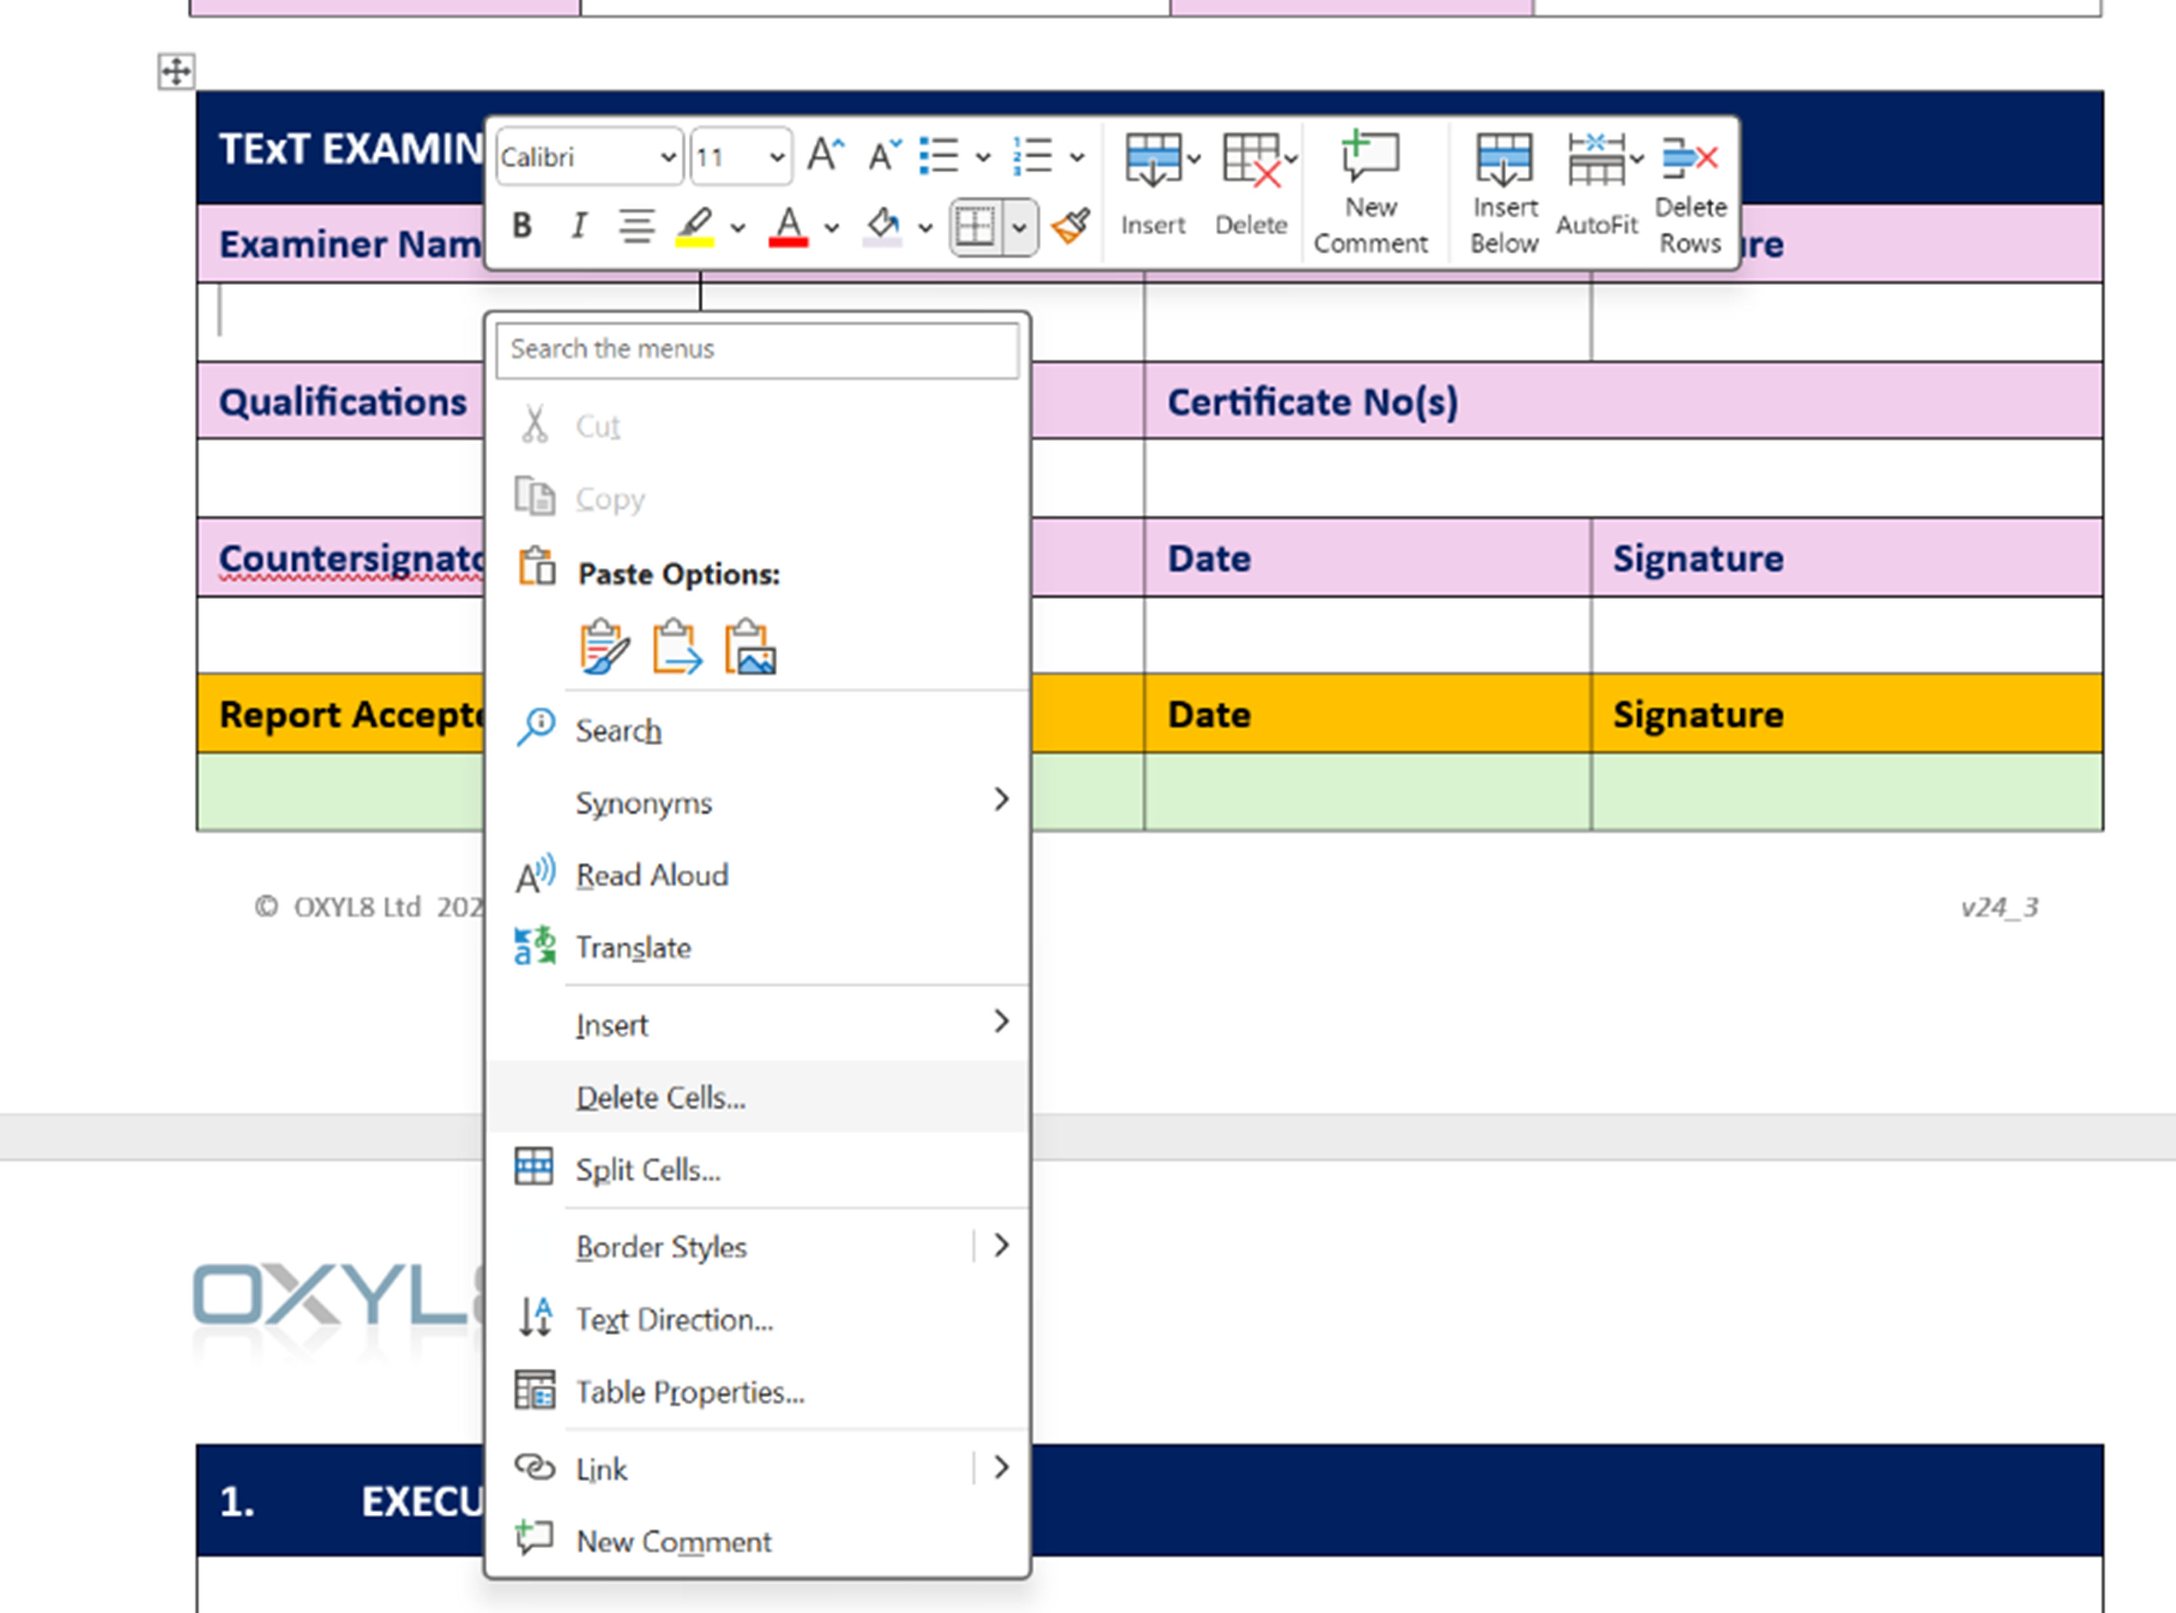

“Insert” will allow you to insert a Row, Column or Cell.
“Delete” – deletes a Row, Column or Cell
“Table Properties” opens up another window (see next page)
This new pop-up window permits most aspects of the Rows, Columns or Cells to be amended.

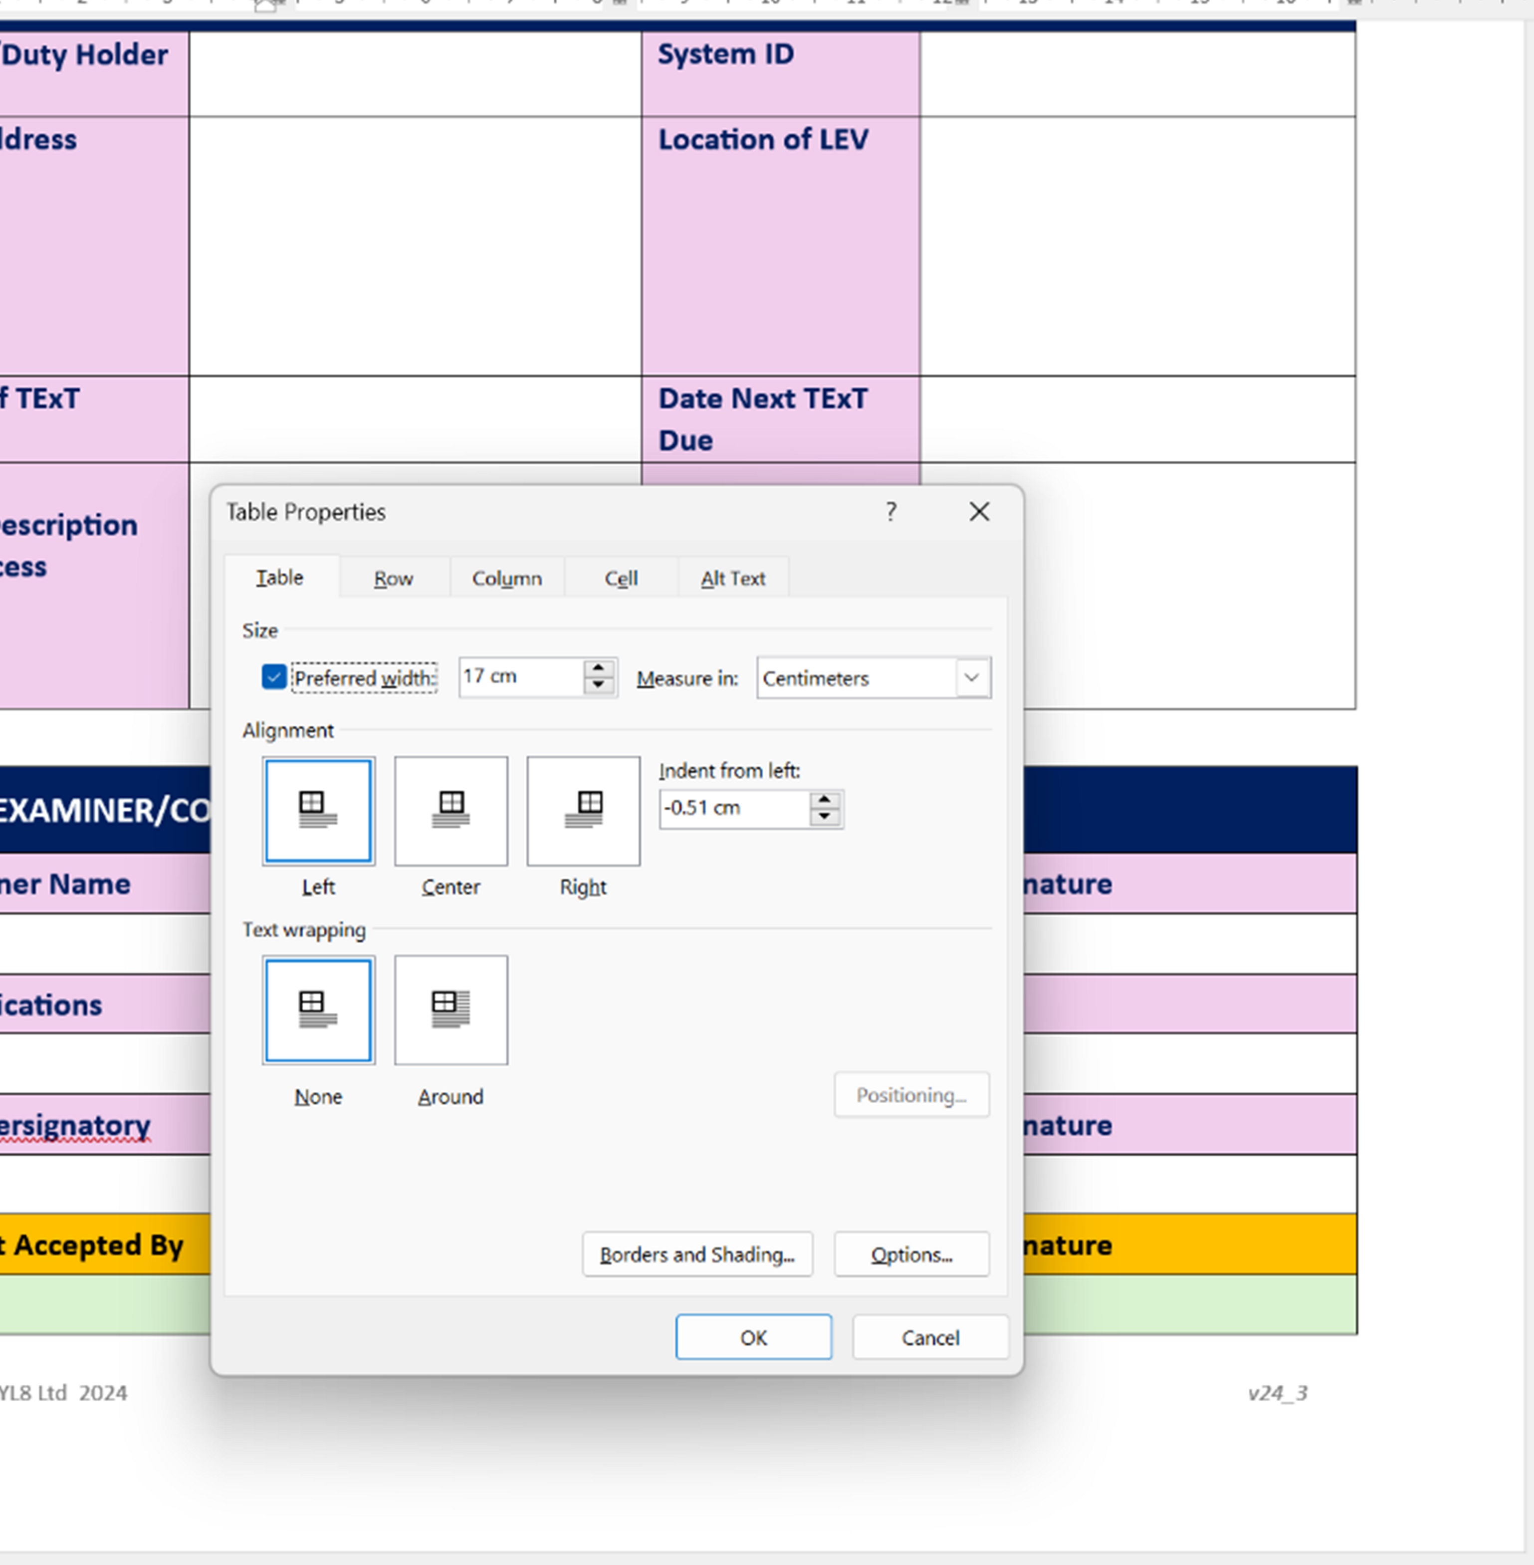

Excel Tables and Embedding into Word Template
The individual Excel tables can be amended and improved using standard Excel functions.
Once an Excel table has been changed to suit your company’s needs ….. first delete the old embedded Excel table from the Word Template by clicking ONCE on it in the Template and then hitting the “Delete” button on your keyboard.
To ‘Insert’ the new Excel table – first from the Word Template top line click the “Insert” tab and then select “Object” – as arrowed in image below:-

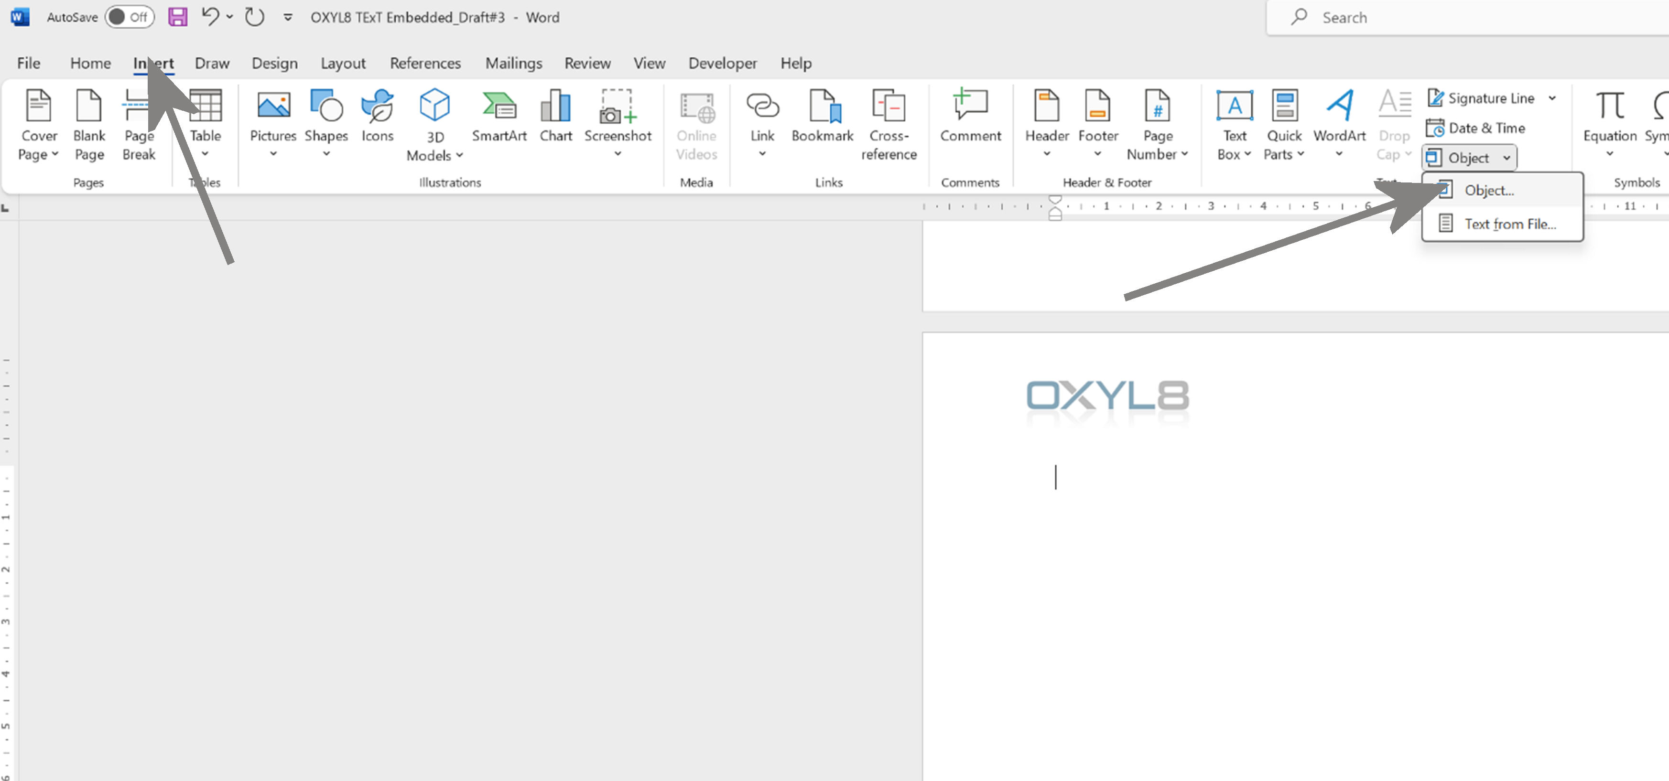

Clicking “Object” will open a pop-up window …… select the tab “Create from File”. Then use the “Browse” button to navigate to the Excel table you have created/amended.
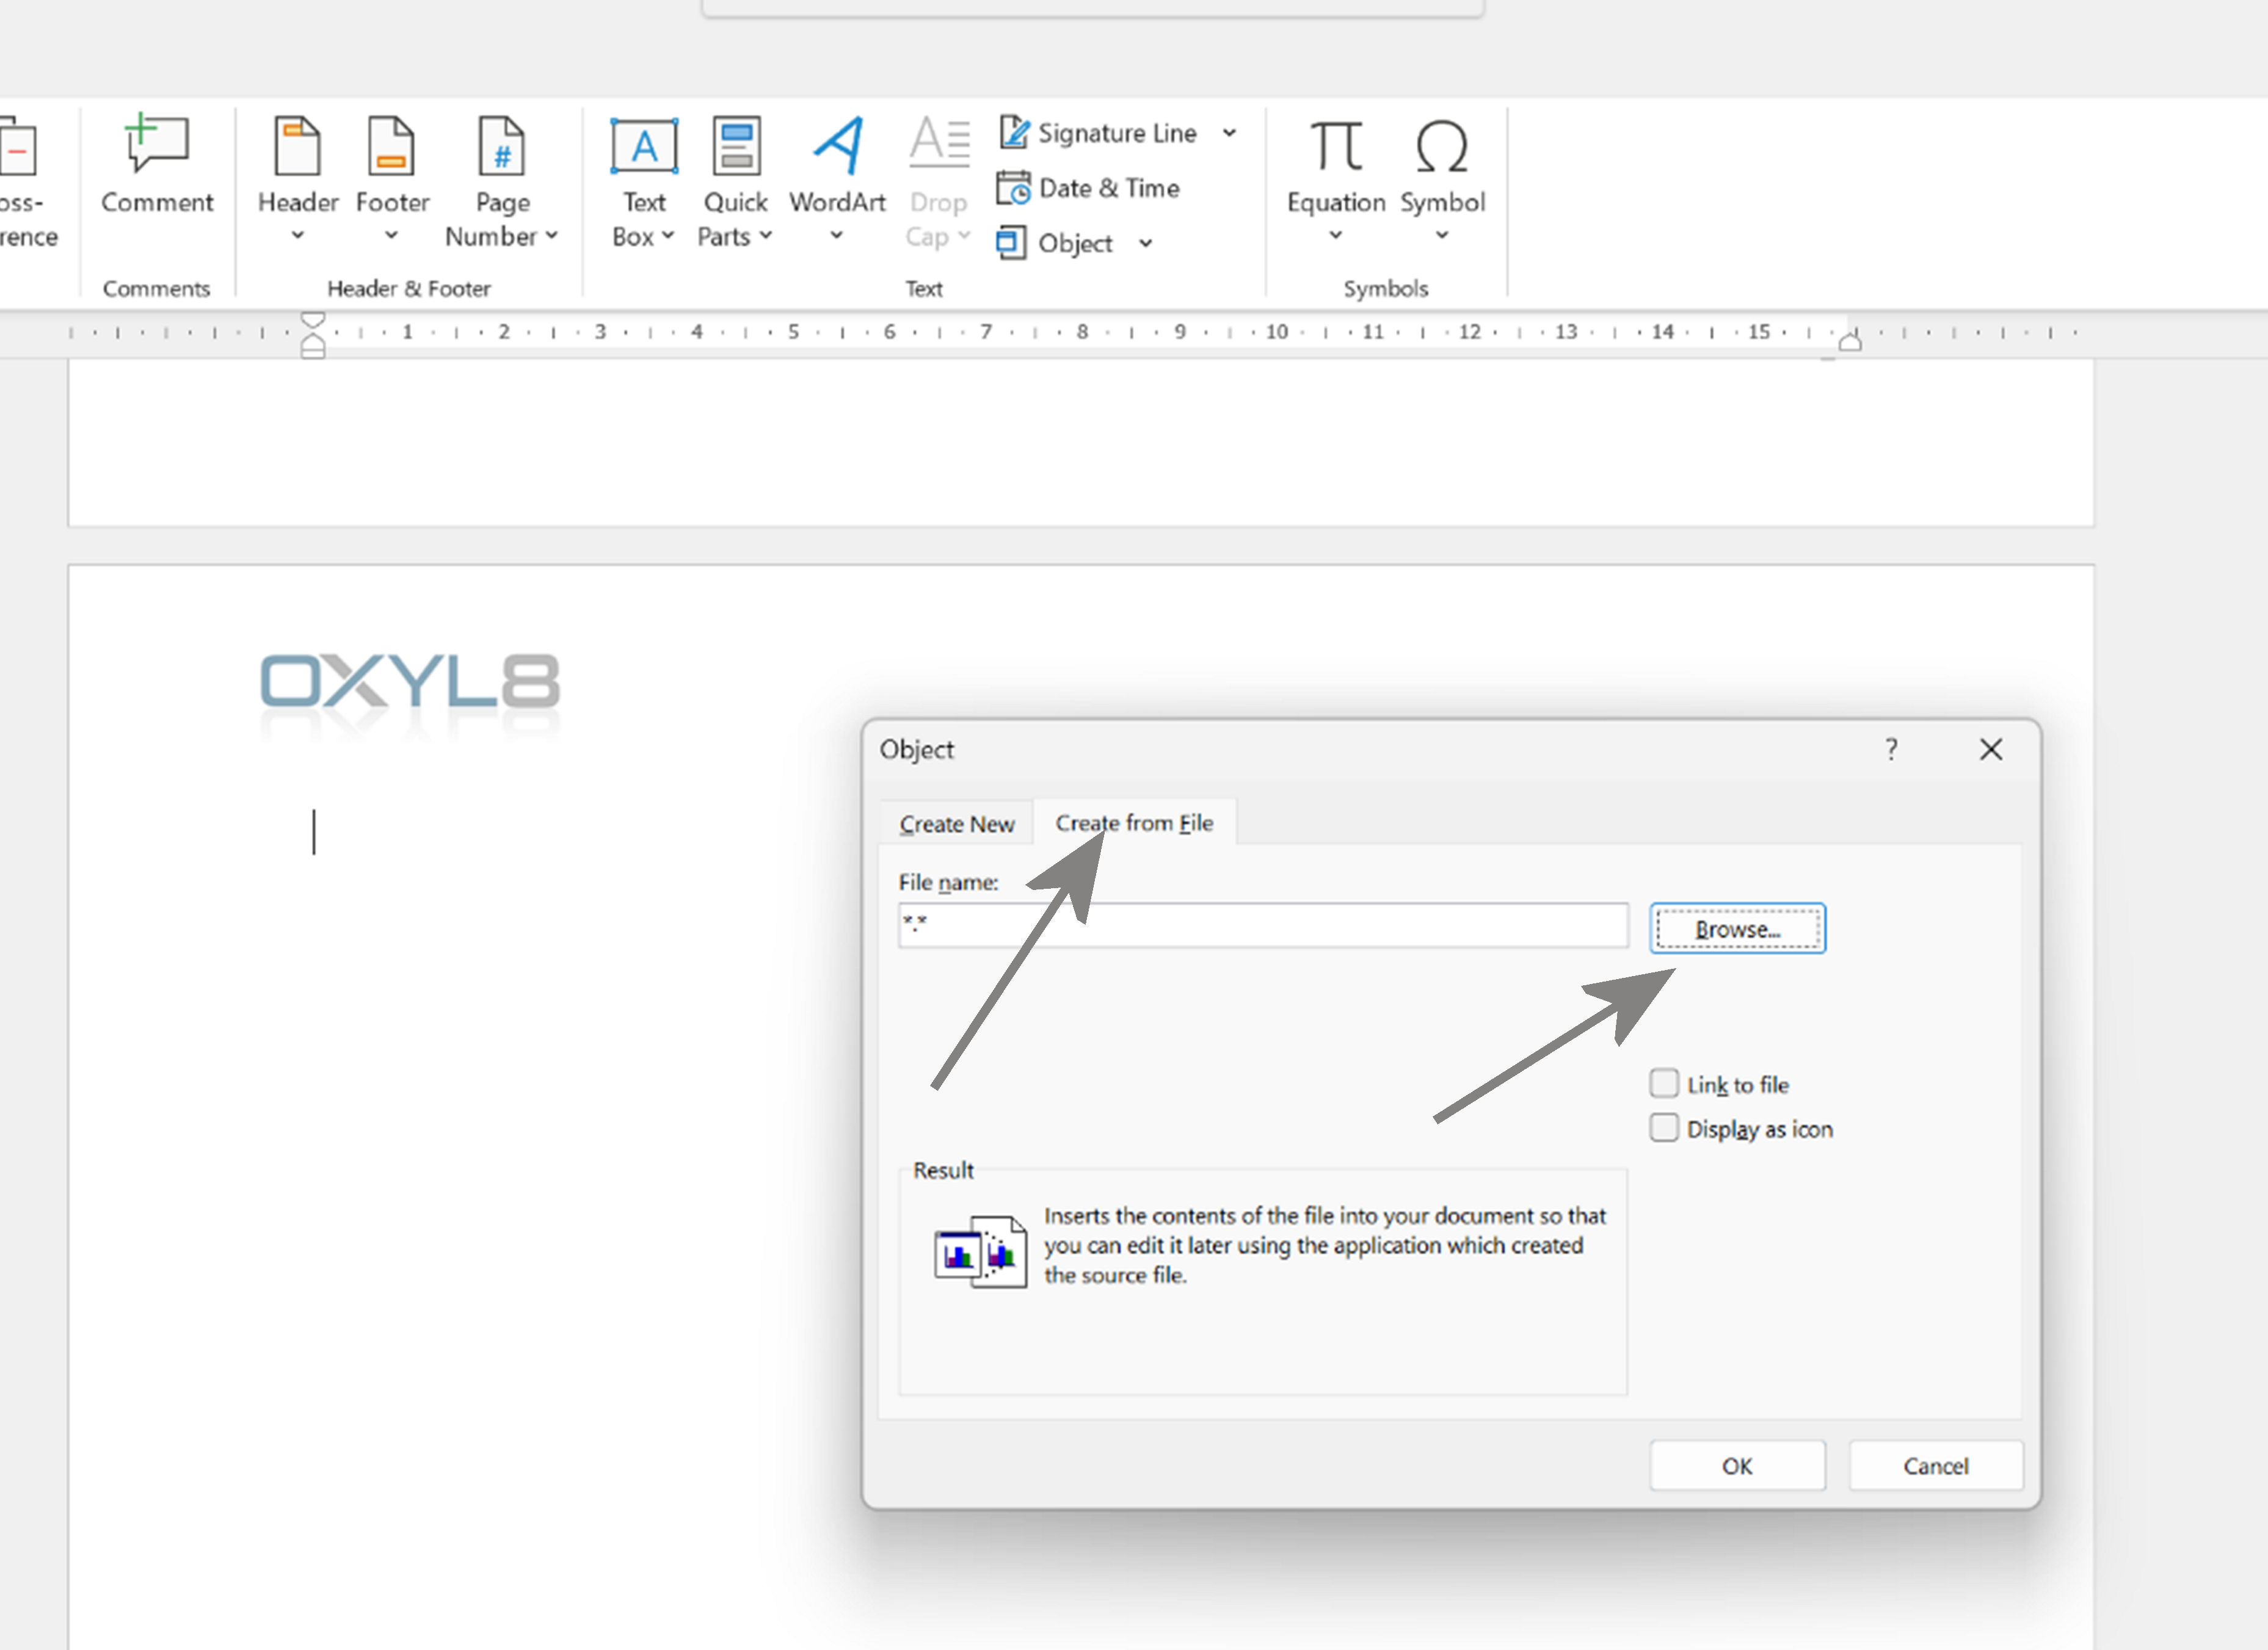

Once you have browsed to the Excel file and clicked “Insert” and then clicked “OK” … that should do the trick and your Excel table will now be embedded into the Word Template.
Resave the Template as a new version.

About OXYL8 Professional Publications
OXYL8 Professional Publications publishes practical guidance, technical monographs and professional resources intended to support Duty Holders and other professionals responsible for achieving and demonstrating effective control of hazardous substances in the workplace.
The publications are developed from practical experience, recognised good practice and current legislation, with the objective of promoting robust engineering, sound governance and evidence-based decision making.
The Duty Holder Guide Series explores the wider principles that underpin effective LEV governance, commissioning, performance verification and ongoing assurance.
Further publications are available at:
www.oxyl8.com

Duty Holder Guide Series
Current Publications
DHG-001
A Duty Holder's Guide: LEV Assurance

DHG-002
Defensible LEV Commissioning

DHG-003
Commissioning vs TExT



OXYL8 Professional Publications
An imprint of OXYL8 Ltd
www.oxyl8.com

